SQL Exercise 7

**Purpose:** Nine SQL exercises will be released throughout the quarter. These assignments will help you connect and manipulate a database through Python. Python-to-SQL is a parallel strand of knowledge that you would gain in this class.

**Reference:** 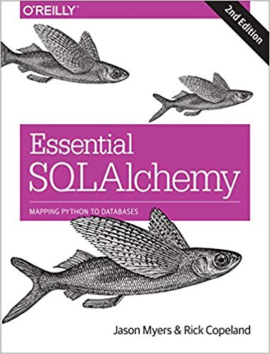

**Code:** Time to practice! Try the code below and get it to work. The code is pre-tested and should run “as is.” Verify what you type if an error persists. Press “Run” to every time you completed a jupyter cell. Because you already have content knowledge of what is a database, most of the code are self-explanatory.

***Instructions:*** *Start a new Python project folder … do not reuse the previous workspace … As with any keyboard-driven console-like environment, developing muscle -memory for the common commands is also part of the learning curve.*

**Viewing database:** To view the database created by Python, you may use a SQL Lite viewer. This tool is posted inside Week #2 in Canvas; look for DB.Browser.for.SQLite-3.10.1-win64

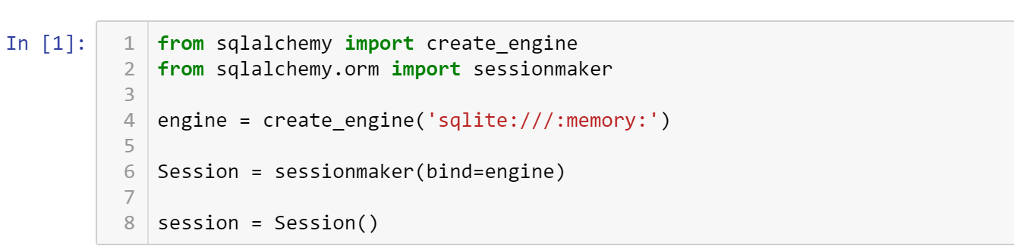

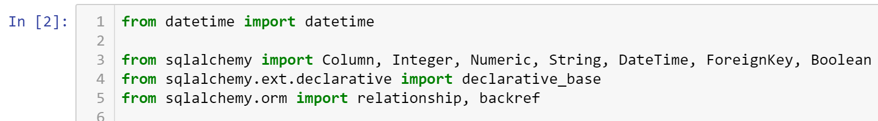

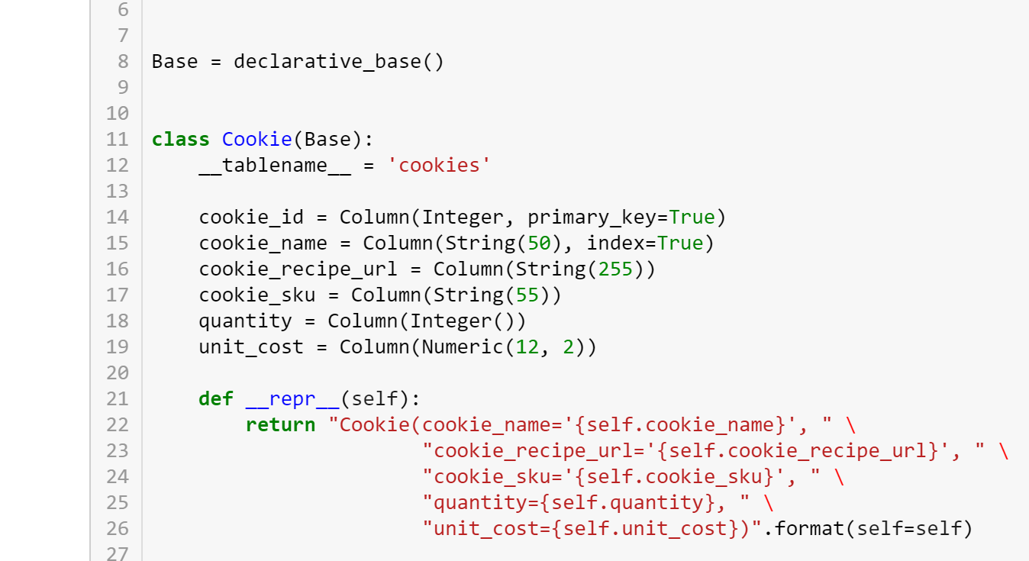

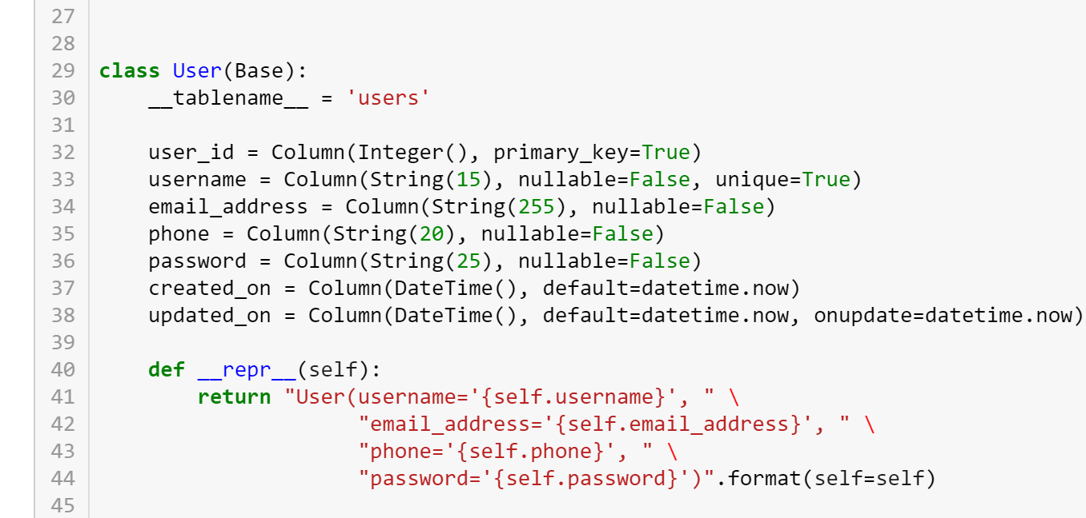

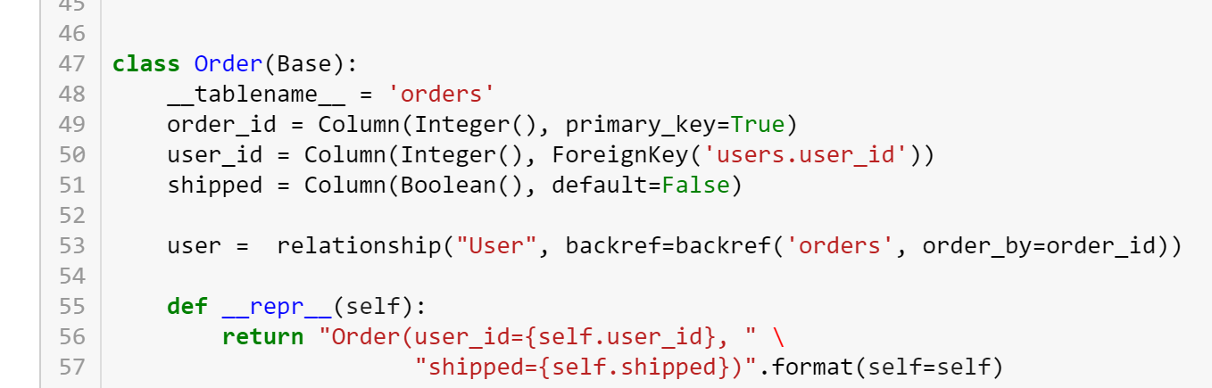

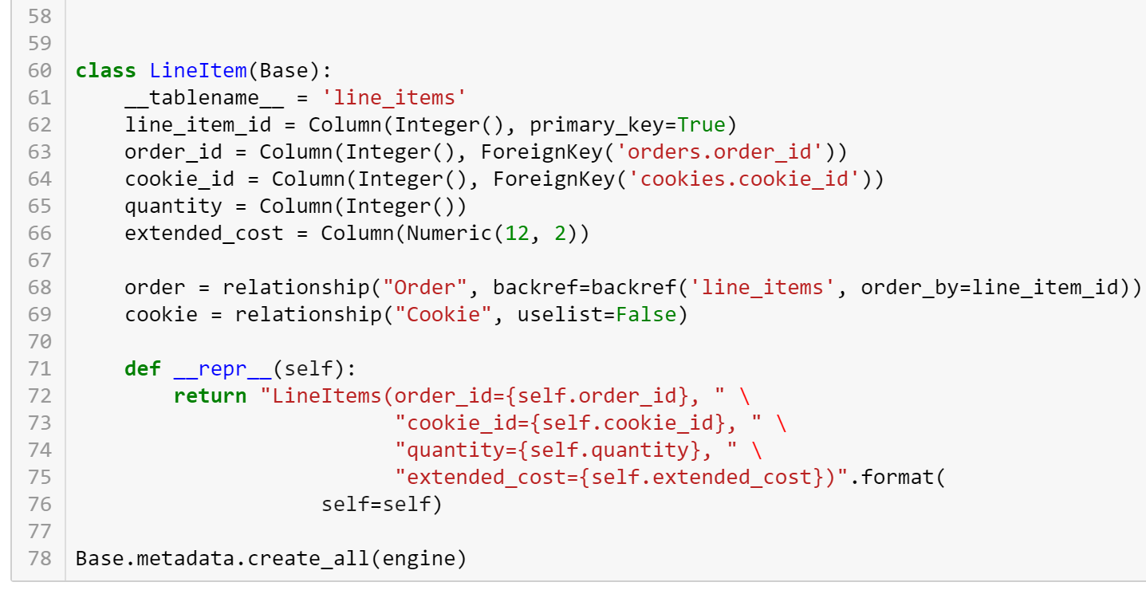

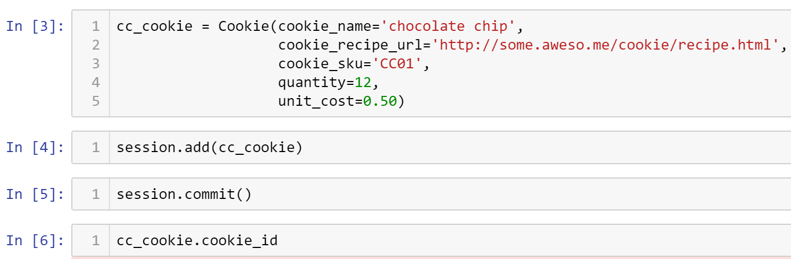

/Users/jasomyer/.virtualenvs/sa-book/lib/python2.7/site-packages/sqlalchemy/sql/sqltypes.py:565: SAWarning: Dialect sqlite+pysqlite does *not* support Decimal objects natively, and SQLAlchemy must convert from floating point - rounding errors and other issues may occur. Please consider storing Decimal numbers as strings or integers on this platform for lossless storage.

'storage.' % (dialect.name, dialect.driver))



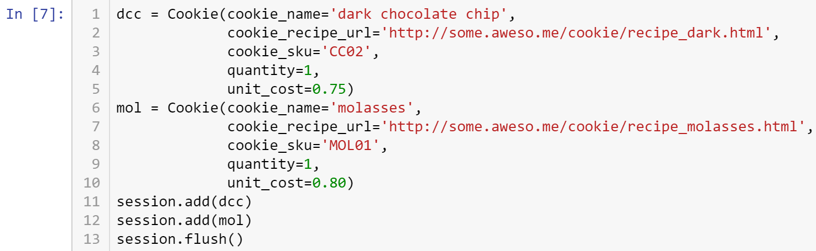

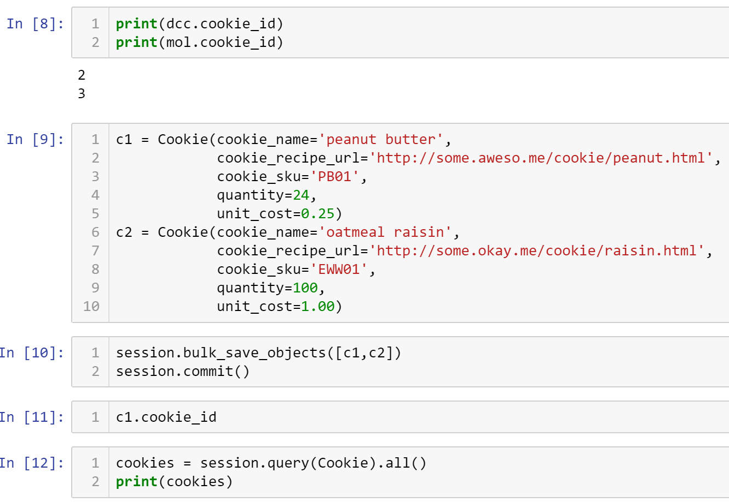

[Cookie(cookie_name='chocolate chip', cookie_recipe_url='http://some.aweso.me/cookie/recipe.html', cookie_sku='CC01', quantity=12, unit_cost=0.50), Cookie(cookie_name='dark chocolate chip', cookie_recipe_url='http://some.aweso.me/cookie/recipe_dark.html', cookie_sku='CC02', quantity=1, unit_cost=0.75), Cookie(cookie_name='molasses', cookie_recipe_url='http://some.aweso.me/cookie/recipe_molasses.html', cookie_sku='MOL01', quantity=1, unit_cost=0.80), Cookie(cookie_name='peanut butter', cookie_recipe_url='http://some.aweso.me/cookie/peanut.html', cookie_sku='PB01', quantity=24, unit_cost=0.25), Cookie(cookie_name='oatmeal raisin', cookie_recipe_url='http://some.okay.me/cookie/raisin.html', cookie_sku='EWW01', quantity=100, unit_cost=1.00)]



Cookie(cookie_name='chocolate chip', cookie_recipe_url='http://some.aweso.me/cookie/recipe.html', cookie_sku='CC01', quantity=12, unit_cost=0.50)

Cookie(cookie_name='dark chocolate chip', cookie_recipe_url='http://some.aweso.me/cookie/recipe_dark.html', cookie_sku='CC02', quantity=1, unit_cost=0.75)

Cookie(cookie_name='molasses', cookie_recipe_url='http://some.aweso.me/cookie/recipe_molasses.html', cookie_sku='MOL01', quantity=1, unit_cost=0.80)

Cookie(cookie_name='peanut butter', cookie_recipe_url='http://some.aweso.me/cookie/peanut.html', cookie_sku='PB01', quantity=24, unit_cost=0.25)

Cookie(cookie_name='oatmeal raisin', cookie_recipe_url='http://some.okay.me/cookie/raisin.html', cookie_sku='EWW01', quantity=100, unit_cost=1.00)

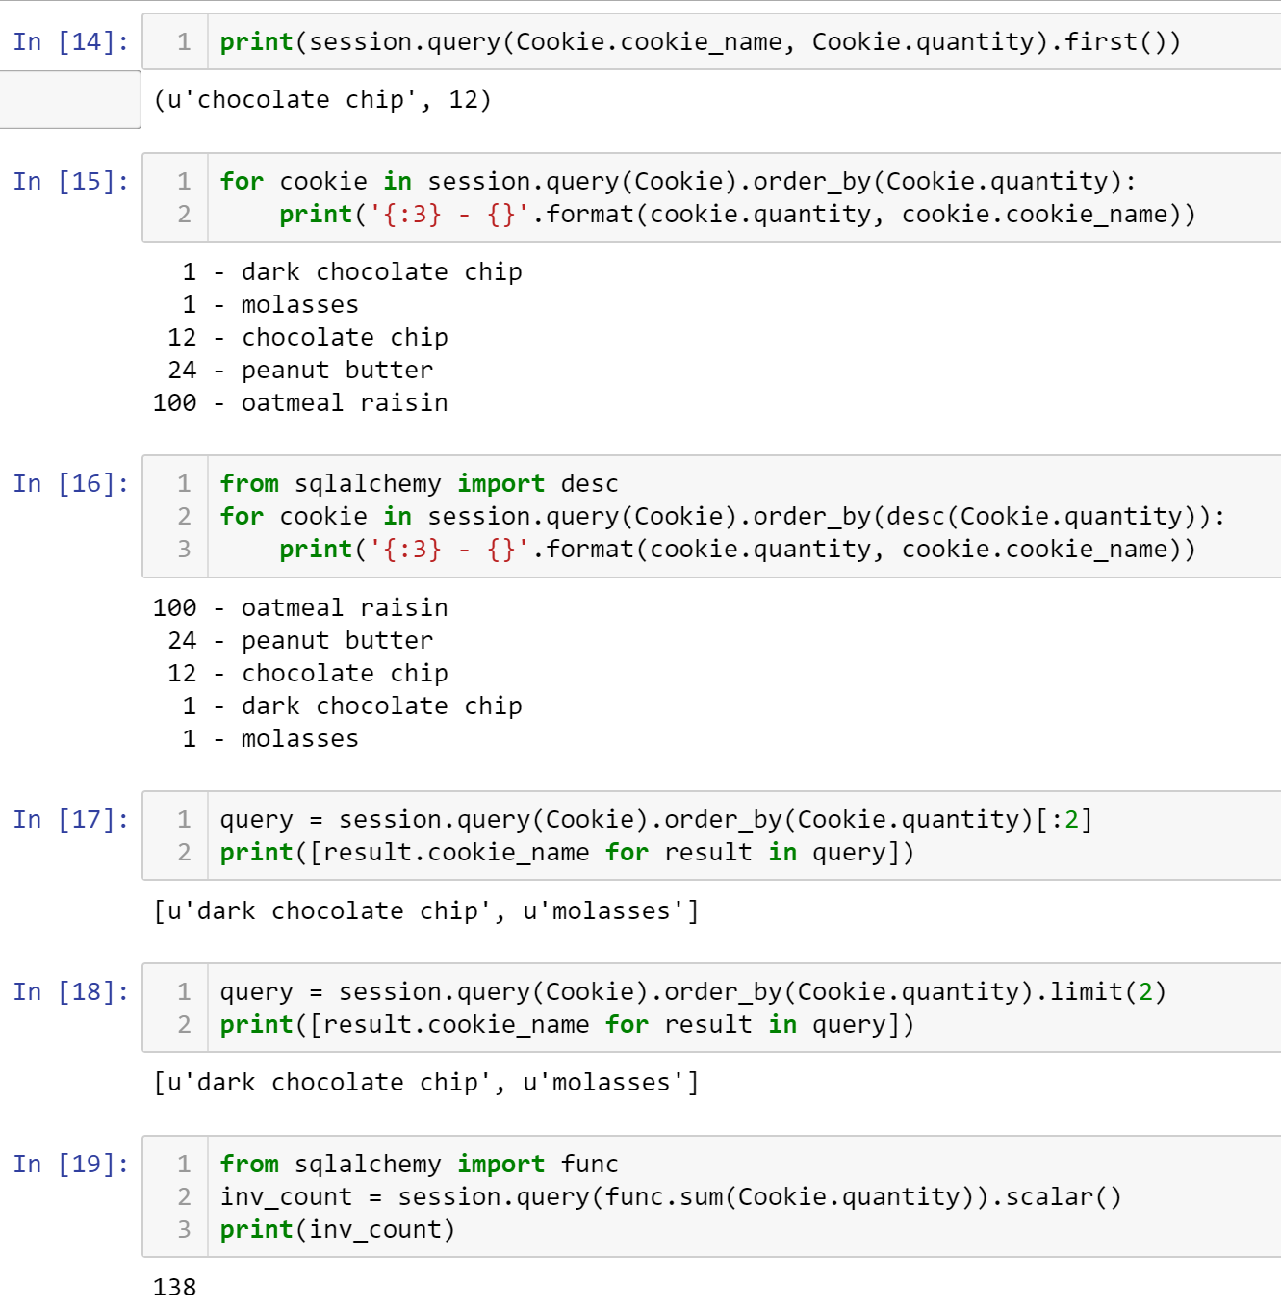

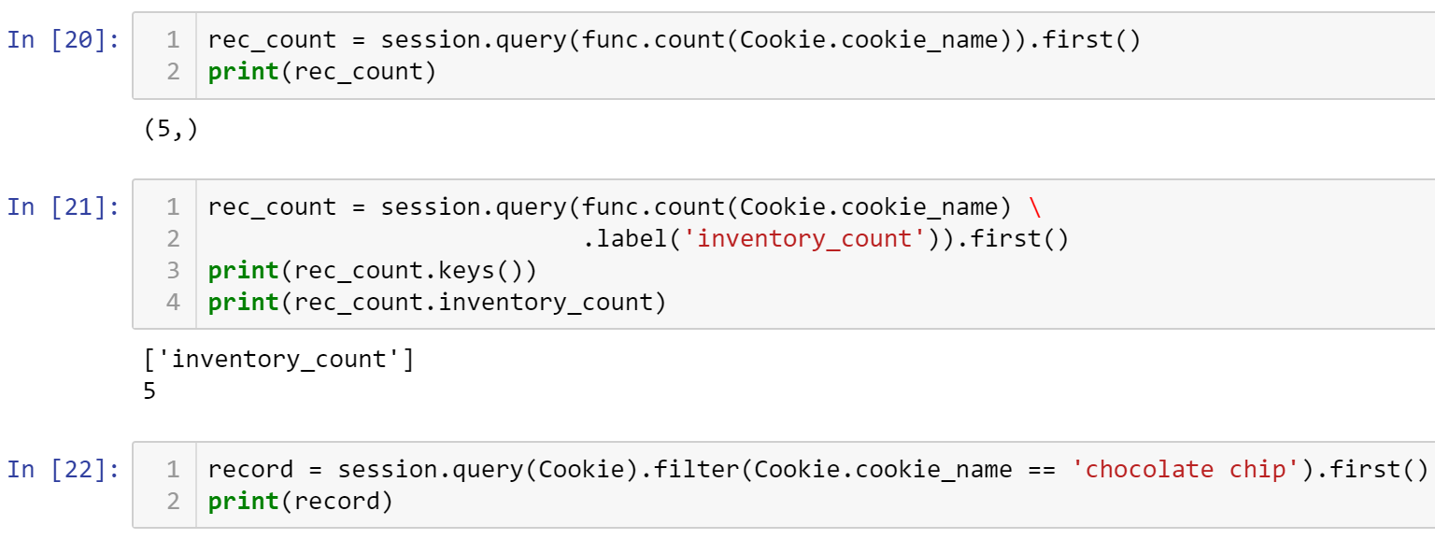

Cookie(cookie_name='chocolate chip', cookie_recipe_url='http://some.aweso.me/cookie/recipe.html', cookie_sku='CC01', quantity=12, unit_cost=0.50)



Cookie(cookie_name='chocolate chip', cookie_recipe_url='http://some.aweso.me/cookie/recipe.html', cookie_sku='CC01', quantity=12, unit_cost=0.50)

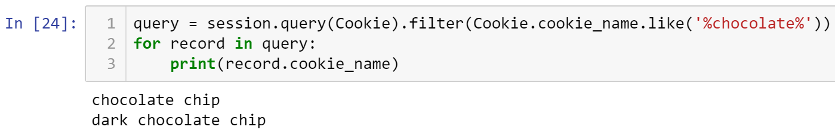

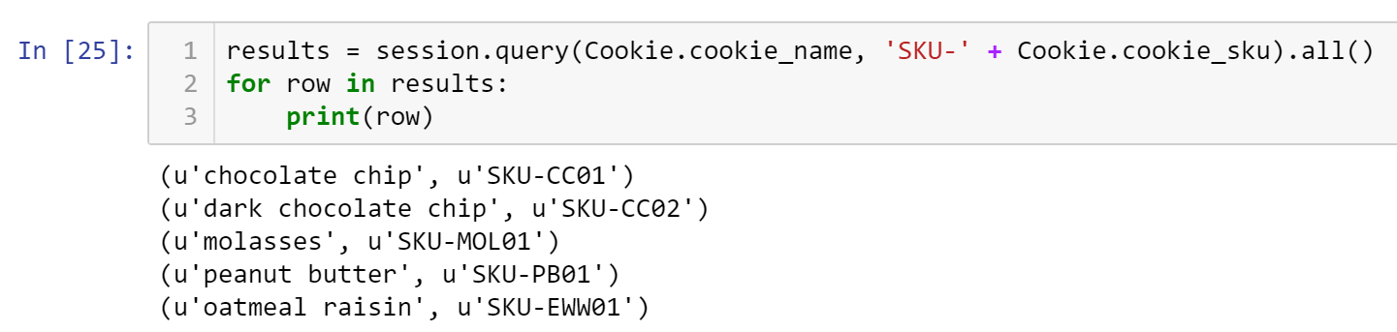

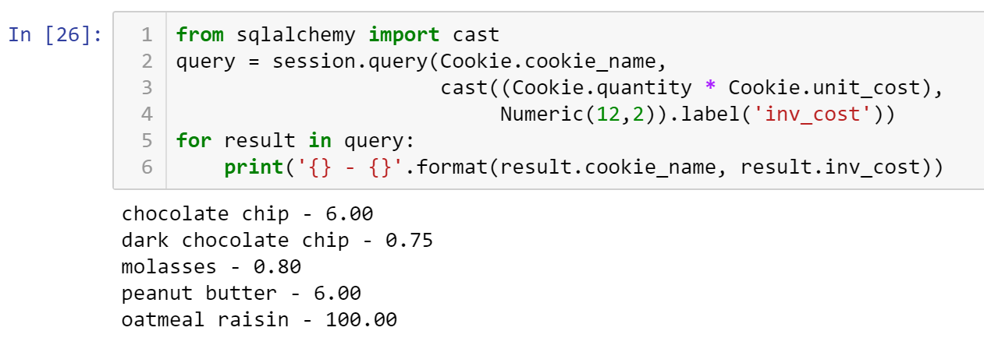

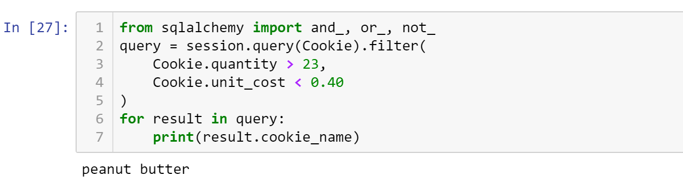

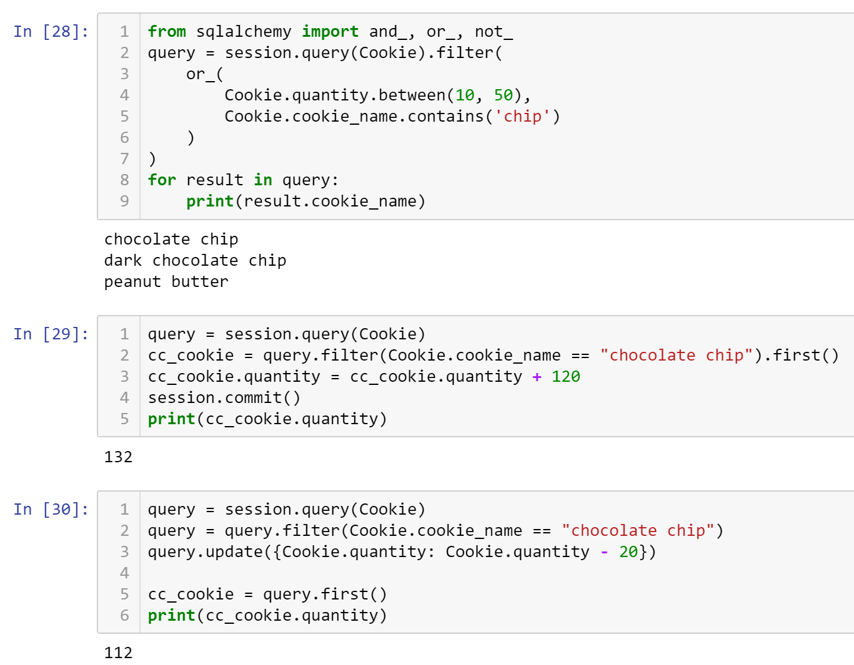

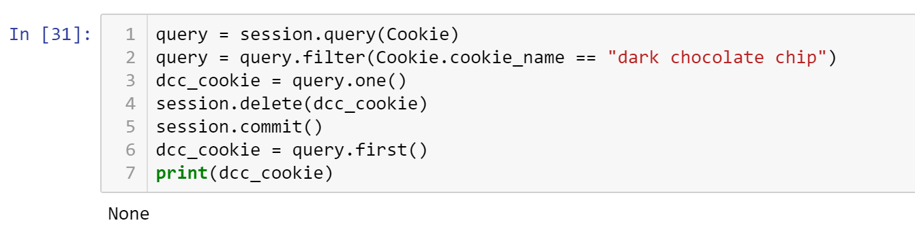

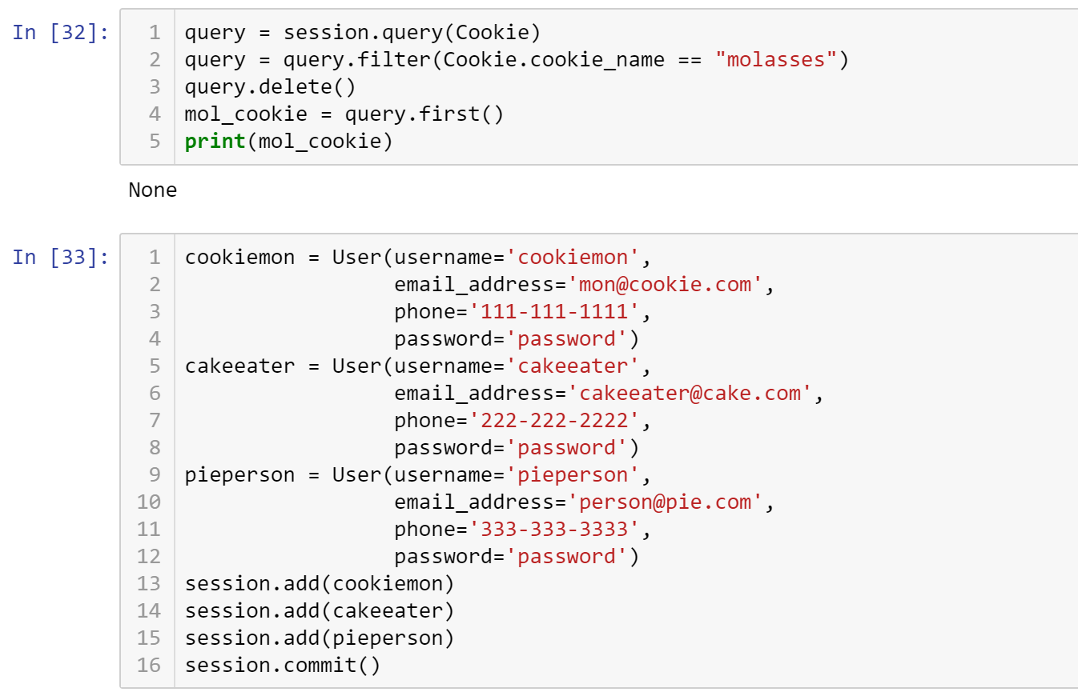

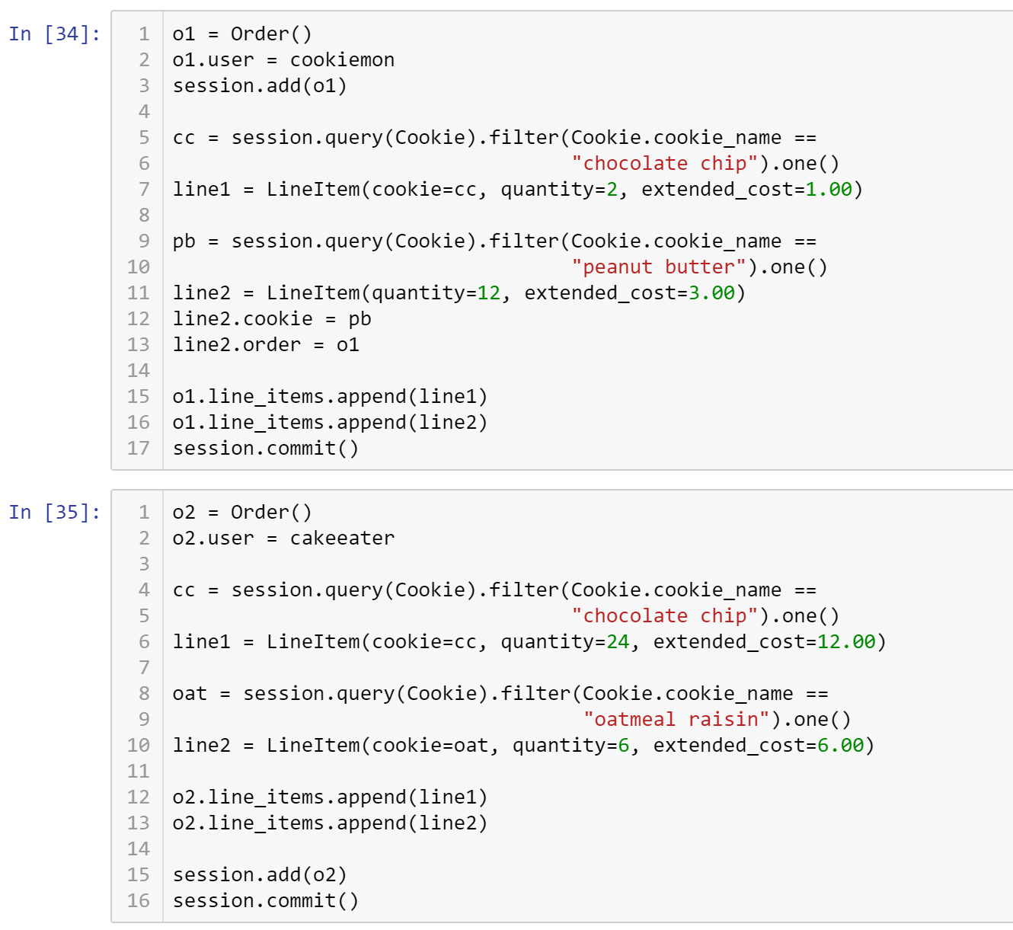



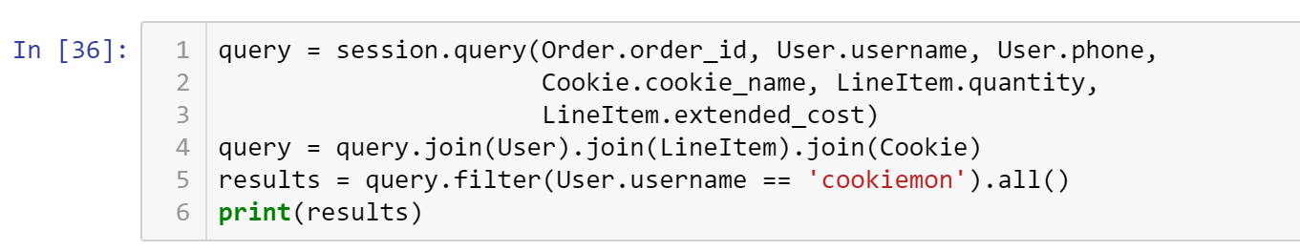

[(1, u'cookiemon', u'111-111-1111', u'peanut butter', 12, Decimal('3.00')), (1, u'cookiemon', u'111-111-1111', u'chocolate chip', 2, Decimal('1.00'))]

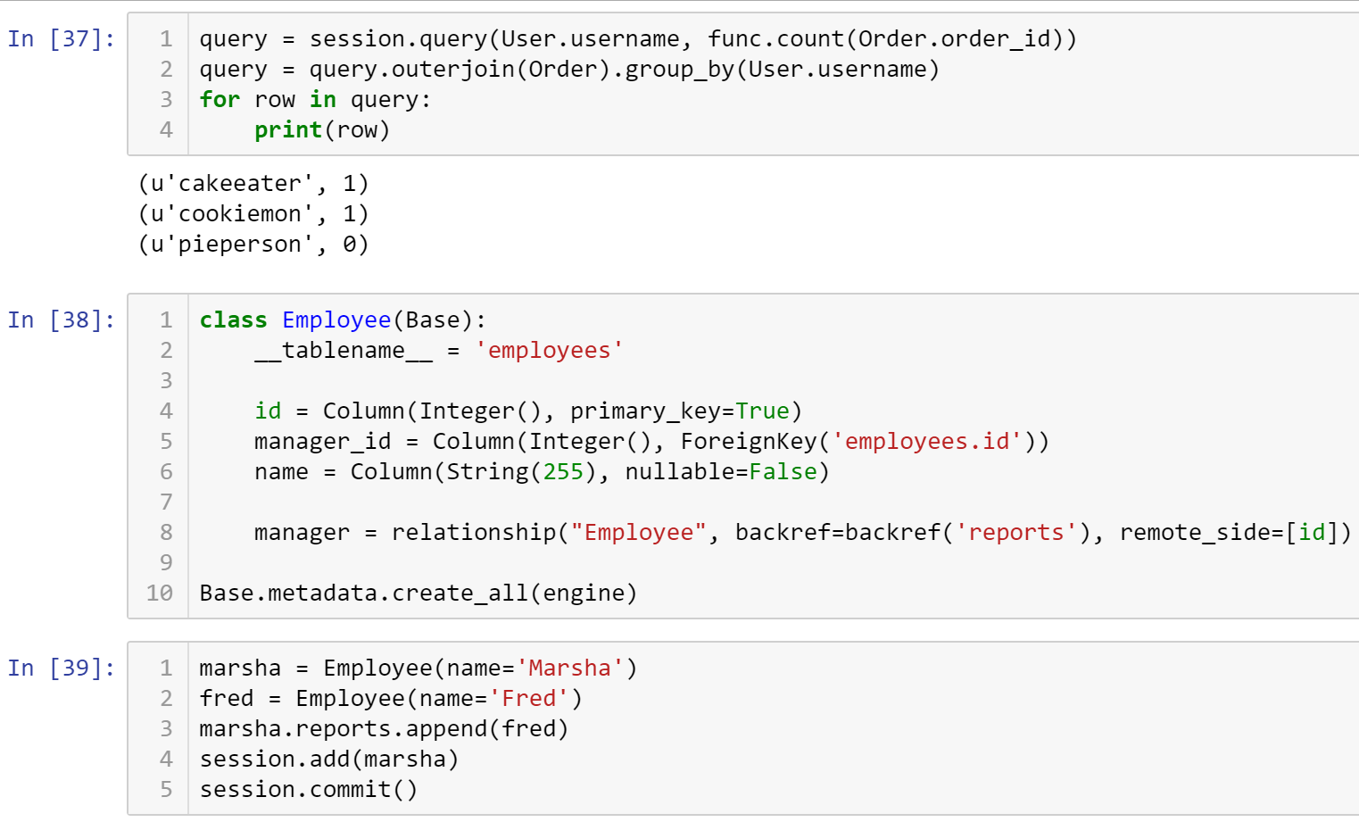

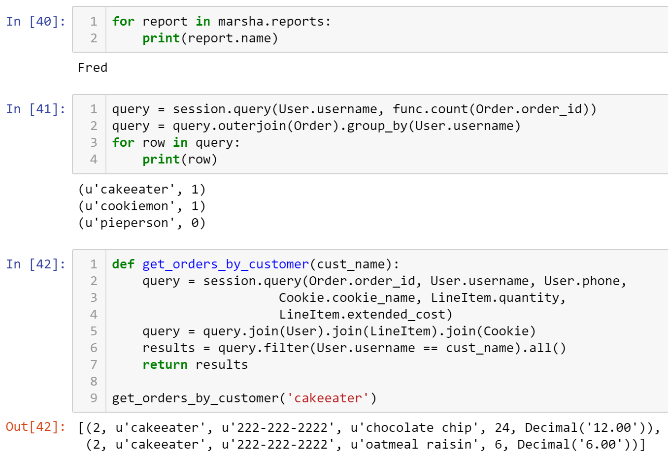

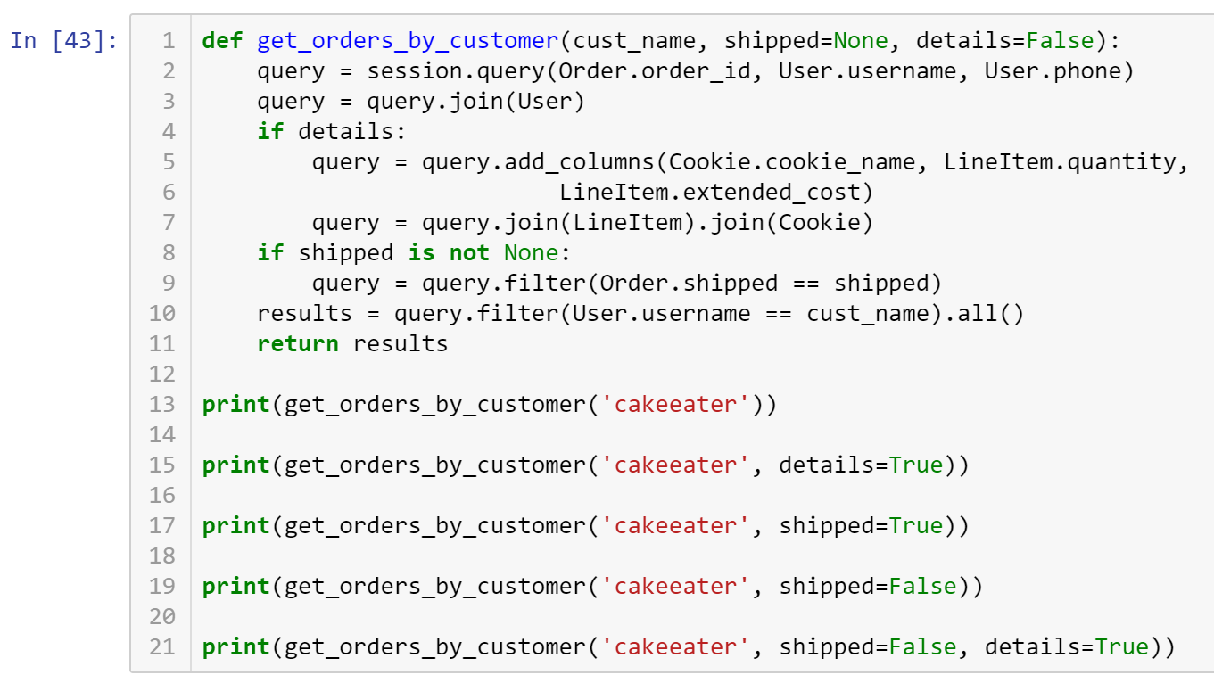

[(2, u'cakeeater', u'222-222-2222')]

[(2, u'cakeeater', u'222-222-2222', u'chocolate chip', 24, Decimal('12.00')), (2, u'cakeeater', u'222-222-2222', u'oatmeal raisin', 6, Decimal('6.00'))]

[]

[(2, u'cakeeater', u'222-222-2222')]

[(2, u'cakeeater', u'222-222-2222', u'chocolate chip', 24, Decimal('12.00')), (2, u'cakeeater', u'222-222-2222', u'oatmeal raisin', 6, Decimal('6.00'))]

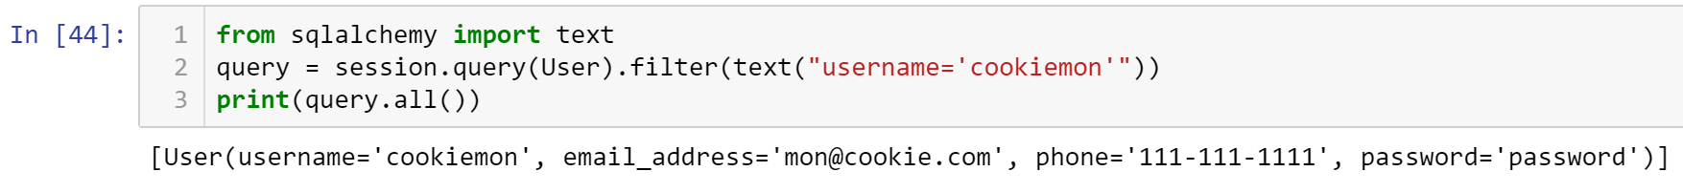

* **Critical Thinking Section:** In your own words, explain in a paragraph (5 sentences or more) describing what you have learned about how Python creates and instantiates custom-made classes.
* Place your answer here below:

|  |
| --- |
|  |

* Place your name at the bottom of your code, download your Python program in html format, and submit your work in Canvas.

**Viewing database:** To view the database created by Python, you may use a SQL Lite viewer. This tool is posted inside Week #2 in Canvas; look for DB.Browser.for.SQLite-3.10.1-win64

**Important:** All submissions should be separate from other exercises and quests. Please do not lump all your answers into one document and re-using that same workspace to gain multiple points. Thanks.